
SEARCH – The KMC Health Sciences Library, Manipal

OpenAthens (SSO - Single Sign-on) - Remote Access to e-Resources
https://go.openathens.net/redirector/manipal.edu?url=https%3A%2F%2Flibportal.manipal.edu%2FKMC%2Findex.asp

Authentication:
- Access to the subscribed e-resources of KMC Health Sciences Library, Manipal remotely is available to all the users (students, researchers and faculty members) of Health Sciences Institutions of MAHE at Manipal campus through OpenAthens account from 1st October, 2021.
- OpenAthens account is configured with the users’ office 365 Outlook email account (manipal.edu/learner.manipal.edu).
- The eligible/authorized users’ authentication have been done through Office 365 (manipal.edu/ learner.manipal.edu) via OpenAthens based on the lists provided by the Health Sciences Institutions of MAHE at Manipal campus.
- Faculty Members
- Undergraduate Students
- Postgraduate Students
- Research Scholars
- Interns
- Junior Residents

How to Access SEARCH – The KMC Heath Sciences Library Web Portal Remotely via OpenAthens?
- Step-1: Clicking the link https://go.openathens.net/redirector/manipal.edu?url=https%3A%2F%2Flibportal.manipal.edu%2FKMC%2Findex.asp
- Step-2: Signing in using Office 365 (manipal.edu/learner.manipal.edu) login credentials to access library web portal which users are already having with them. Users with @manipal.edu or @learner.manipal.edu email address must use the first sign-in option: MAHE University Microsoft Azure.
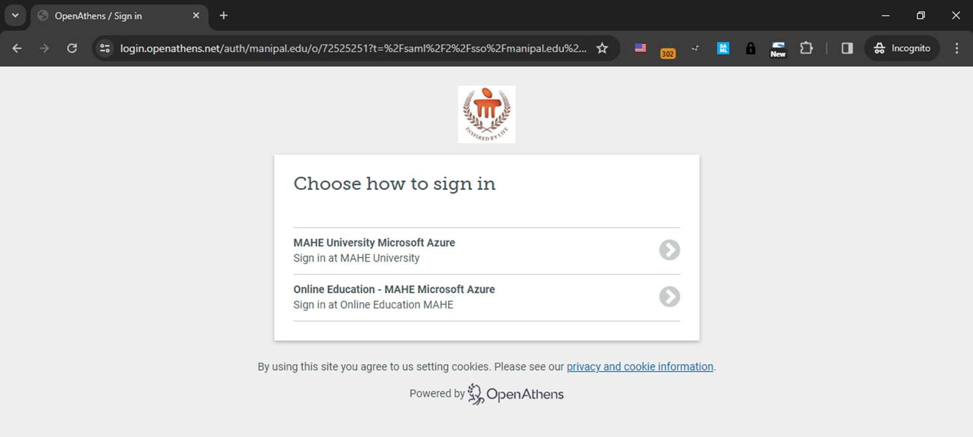

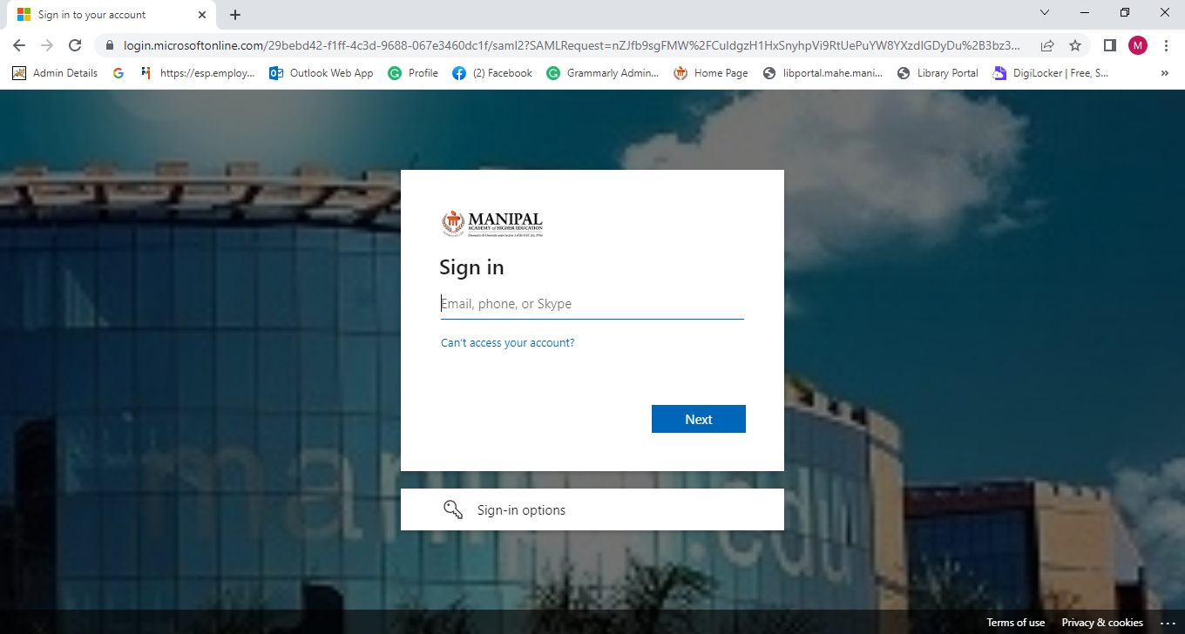
- Step-3: As soon as 2nd step is completed, SEARCH – The KMC Health Science Library web portal will be displayed and then e-resources could be accessed through the same.
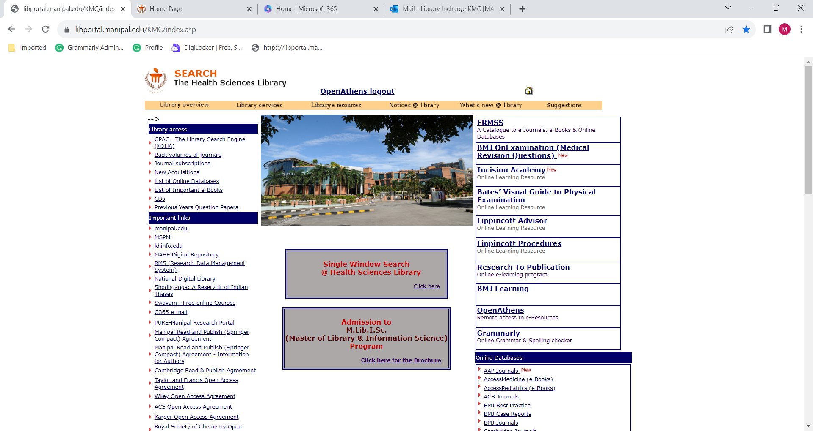

What is OpenAthens?
- OpenAthens – Single Sign-on (SSO) to enable the users of the library to access all the subscribed e-resources (online databases, online journal and e-books etc.) remotely (using their office 365 - learner.manipal.edu/manipal.edu login credentials)
- Integrated with Microsoft office which avoids accessing of the e-resources by unauthorised users.
- OpenAthens creates a single sign on experience that is independent of any specific IP range
- User could also access full-text of the subscribed e-resources through the respective publishers’ website as OpenAthens user name and password permits the access - Single Sign-on. Providing users with access to many different systems through a single set of login details.

Contact:
Users may please contact the KMC Health Sciences Library, MAHE, Manipal at 0820 2922609/2922358 or by e-mail to lib.kmc@manipal.edu in case of any remote access related issues/clarifications.

